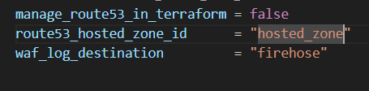
manage_route53_in_terraform = false
This says: “Don’t create/manage the Route 53 Hosted Zone with Terraform.”
So your code will typically:
- skip aws_route53_zone resources (often using count = var.manage_route53_in_terraform ? 1 : 0)
- instead, it will use an existing hosted zone (the one you provide in route53_hosted_zone_id) when creating DNS records like aws_route53_record.
Practical meaning: Route 53 zone already exists, Terraform won’t touch it.

route53_hosted_zone_id = "hosted_zone"
This provides the Hosted Zone ID for the domain you want Terraform to create records in.
When manage_route53_in_terraform = false, your module needs this so it knows where to put records like:
- apex A record → CloudFront
- app.yourdomain.com → CloudFront
- origin.yourdomain.com → ALB
This ID is the “container” for DNS records in Route 53.

waf_log_destination = "firehose"
This is a feature toggle for where WAF logs should go.
When set to "firehose", your module will usually:
- create (or enable) a Kinesis Data Firehose delivery stream
- create an S3 bucket for the delivered logs
- create an IAM role/policy Firehose uses to write to S3
- set up aws_wafv2_web_acl_logging_configuration to send WAF logs to that Firehose stream

